

*shell programming lab*

aSsignment -15

**SUBMITTED BY: SUBMITTED TO:**

**AYUSH KUMAR JHA Dr. Dhiviya Rose**

**SAP ID - 500086400**

**Enrollment no - R200220083**

**B.C.A -I.O.T.**

**TITLE:**Shell Scripts reading Files

**Activities:**

Working with getopts

1. Create a bash script to get the command line argument and print it. Use $0,$1,$2,$3,$@,$* by passing suitable command line arguments.

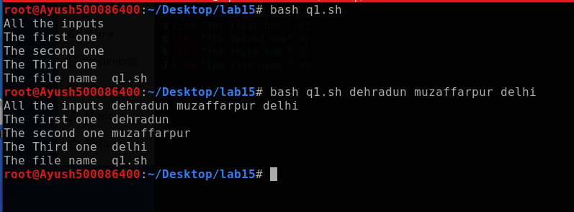

1. Create a bash script to get the command line argument with options using case block.

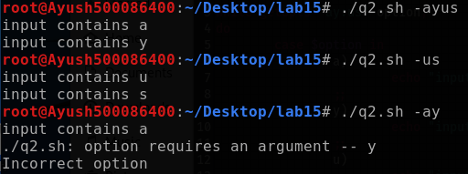

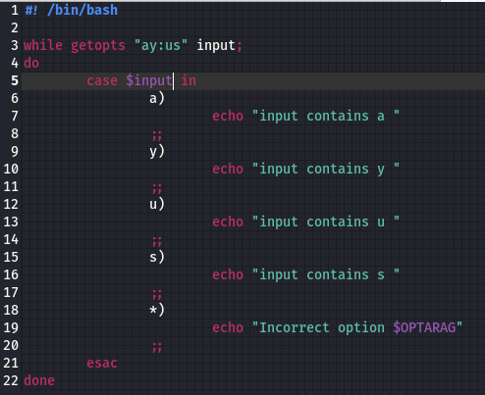

1. Create a bash script Parse input arguments with if condition and while loop.

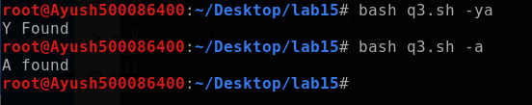

\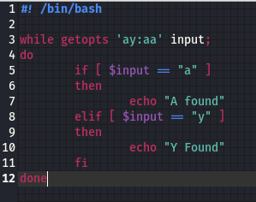

Reference:

https://www.golinuxcloud.com/counter-in-bash/